The Spring Pack - Product Application Guide
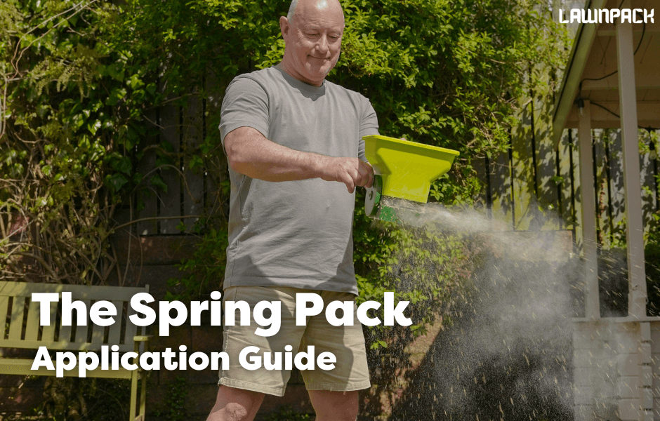
The Spring Pack is the perfect combination to turbocharge green growth throughout the spring months.
The pack combines Greener Growth Fertiliser and Biostimulant Booster to deliver exceptional results for your lawn. The fertiliser provides a balanced blend of fast- and slow-release nitrogen for rapid, vibrant green growth within days and sustained lushness for up to 12 weeks. It thickens and revitalises lawns while being safe for pets and children. The Biostimulant Booster enhances root depth, density, and soil microbiology. When applied at the same time as the fertiliser it promotes nutrient absorption which maximises the benefits of both products. Together, these products ensure a thriving, resilient lawn with long-lasting vibrancy. Best applied March - May.
Greener Growth Fertiliser
Apply the seasonal fertilisers evenly across the lawn at 25-35g per SQM ideally with a spreader.
Biostimulant Booster
Apply 4-5ml per SQM of the Biostimulant Booster using a watering can with a fine rose head or using a pump/pressure spray.
The biostimulant must be diluted in water before application. The amount of water needed for your lawn size is on the label.
Maintenance
- Weed control: You can apply selective herbicides such as Weedol for Lawns when the weeds start growing (roughly end of March). Don’t apply selective herbicides until 8 weeks after seeding or from 6 weeks beforehand as the affect germination.
- Mowing: Wait until your lawn is dry enough. Set the mower on the highest setting for the first cut of the year before bringing it down gradually. Don’t cut off more than ⅓ at a time. By the end of spring when the grass is growing fast you can be mowing 4-7 days. Mowing more frequently improves the condition of the lawn.
- Renovation: Spring is arguably the ideal time to get seeding. When seeding, we recommend applying The Lawn Pack renovation kit which contains different fertilisers to this pack. The nitrogen content in the Greener Growth Fertiliser will cause the existing grass to grow too fast and outcompete the new seedlings.
- Moss control: If you have any moss which needs removing then apply Deeper Green Iron Sulphate across the lawn and rake out after 14 days when the moss has turned black. Deal with underlying conditions such as poor drainage to help prevent moss returning in the future (see next point).
- Scarification/Aeration: Spring is a good time to scarify and aerate your lawn. Scarification will remove dead material in the lawn while aeration will improve the drainage and compaction (the latter only if you are using a hollow-tiner). Both will improve grass health by helping the flow of air, water and nutrients.

What's Up Next?
In 8-12 weeks, it's time to apply the Summer Pack! Give your lawn what it needs to stay greener for longer in the summer months. Applied June - August.
Summer Thriver Fertiliser is specially formulated for summer and can be applied in periods of high temperatures and low rainfall without the risk of scorching. It still has high nitrogen for green growth as well as stress-relieving properties to help your lawn stay green. Also contains Biostimulant Booster.

